KuKula  A Cognitive Relief System for the Mozambican Student |   HCI Final Assignment – Part 1  4th Year, Semester VII | 2026 | Computer Science  Universidade São Tomás de Moçambique (USTM)  Student Name: Neyton Muhlanga  Lecturer: Eng. Marciano Ombe

1. Project Idea and Problem Statement
Project Title: KuKula — A Cognitive Relief System for the Modern Mozambican Student

The domain of this project is higher education technology, specifically the academic productivity challenges faced by undergraduate students in Mozambique. KuKula is a mobile application prototype designed for students at USTM (Universidade São Tomás de Moçambique) in Maputo, exclusive in it’s first phase and then inclusive (for all universities) progressing through other phases, targeting the real constraints of university life in our environment: expensive and limited mobile data, intermittent internet connectivity, long daily commutes, and university systems that are neither integrated nor user friendly.

The core problem this system addresses is what Don Norman calls the "Gulf of Execution" — the cognitive distance between a student's intention to study and the actual start of that task. In practice, this gulf is widened by Institutional Fragmentation: deadlines are scattered across WhatsApp groups, physical notice boards, and the SIGES portal, while personal study plans live in separate notebooks or not at all. Students spend more cognitive energy organising what to do than actually doing it.

My motivation is personal. I have missed deadlines because notifications got buried in group chats. I have felt the paralysis of not knowing where to start after a long day. KuKula is designed to eliminate that paralysis by applying established HCI principles within a product built for our specific reality, not imported from a different context.

2. User Research

Target Users and Personas
I developed two personas representing contrasting extremes of the user base, ensuring the design decisions are stress tested against different real world situations.

Persona 1: João Machava — The Commuter (3rd Year, Computer Science)
Age | 22
Location | Matola, commuting daily to USTM Maputo
Context | Spends approximately 3 hours per day on chapas. Purchases mobile data in small bundles of 150 to 500MB.
Pain Points | Cannot access the SIGES portal during commutes. Misses deadlines because assignment briefs shared as PDFs in WhatsApp get buried or opened too late.
Goals | A single, offline capable view of his entire week's obligations, usable during his 45 minute commute without consuming data.
Quote | "I spend more time finding out what to study than actually studying."

Persona 2: Nádia Cumbane — The Working Scholar (Final Year, Business Informatics)
Age | 25
Location | Maputo City, works full time and attends evening classes
Context | Works 08:00 to 17:00, attends classes 18:00 to 22:00. Has at most 30 to 45 minutes before bed to study.
Pain Points | Severe decision fatigue by evening. Existing apps feel cluttered and demand too much setup. She needs the system to tell her what to do, not just list everything.
Goals | A focus timer that removes distraction and a progress view that confirms she is keeping up, even with limited study time.
Quote | "I don't need a list. I need a plan that respects how tired I already am."

Key User Needs and Goals
- Offline first access: the app must function fully without internet, caching all data locally and syncing when connectivity returns.
- Centralised task visibility: one place for all deadlines, lectures, exams and personal study sessions.
- Low friction interaction: every core action (adding a task, starting a session, checking progress) must be reachable in three taps or fewer.
- Meaningful feedback: the system must confirm actions, celebrate completions, and show progress visually to maintain motivation.
- Localised experience: language support in English, Português and Changana, and use of local academic terminology such as SIGES portal and MZN for fee tracking.

3. Interaction Design Approach
KuKula employs a hybrid interaction style, drawing from three paradigms chosen to serve different moments in the student's day.

Direct Manipulation is the primary interaction style. Task cards are tangible objects that users tap to expand, swipe to change state, and check off with a single touch. The Pomodoro session estimator uses a physical plus and minus stepper that mimics a dial, giving users a concrete sense of adjusting a value rather than typing an abstract number. Shneiderman's direct manipulation principle holds that this style works because effects are visible immediately, providing the rapid feedback that fatigued users need.

Form based interaction is used contextually on the Add Task screen. Rather than a blank text interface, KuKula uses structured fields with sensible defaults (today's date, the previously selected subject) and chip selectors in place of dropdown menus. This is a direct application of Nielsen's sixth heuristic, Recognition over Recall: the user selects from visible options rather than having to remember subject names or date formats.

Focus Mode operates as a Forcing Function (Norman, 2013). When a session begins, all navigation disappears. The only available actions are watching the timer and ending the session. This is not a limitation but a deliberate design decision: constraining available actions guides the user toward the correct behaviour. For a student tempted to check social media, removing that option at the system level is more effective than any reminder.

These choices are grounded in three core HCI theories. Don Norman's Seven Stages of Action underpins the minimal tap philosophy, ensuring the Gulf of Execution is kept as narrow as possible at every screen. Nielsen's 10 Usability Heuristics provide the evaluative framework for each design decision, from status visibility to error prevention. Shneiderman's 8 Golden Rules, particularly Rule 6 (Reduce Short Term Memory Load), drive the colour coding system and persistent progress bars that ensure users never have to recall their academic standing because the interface always shows it.

4. Wireframes and Storyboards
The prototype consists of ten screens presented as low fidelity, monochromatic wireframes designed at iPhone 14 dimensions (390x844px). Each screen is annotated with the specific HCI principle it embodies. The wireframes are grouped below by functional cluster.

Screens 0, 1 and 2: Login, Onboarding and Dashboard
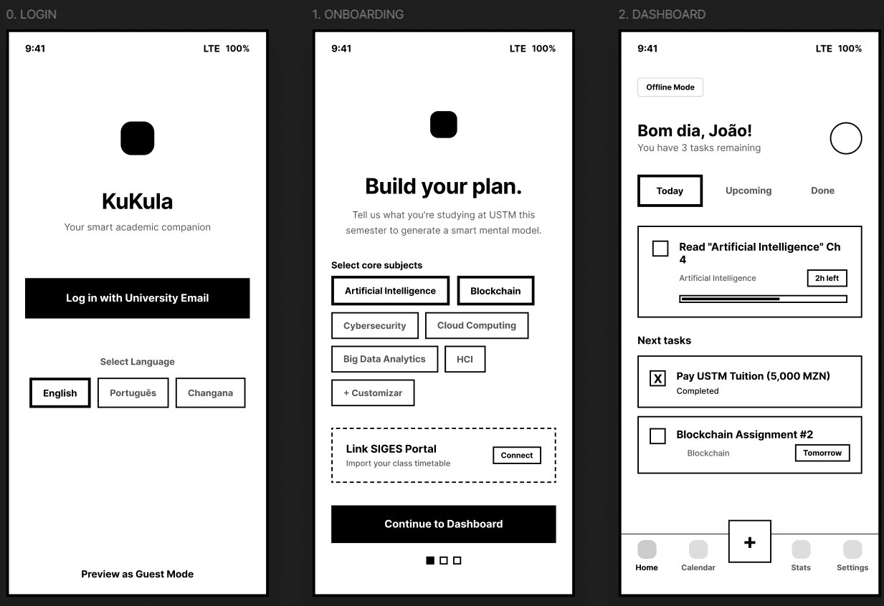
Figure 1 — Login (recognition over recall, guest mode), Onboarding (mental model alignment via stepper), Dashboard (system status via countdown badges and offline indicator)

Screens 3, 4 and 5: Add Task, Calendar View and Task Detail
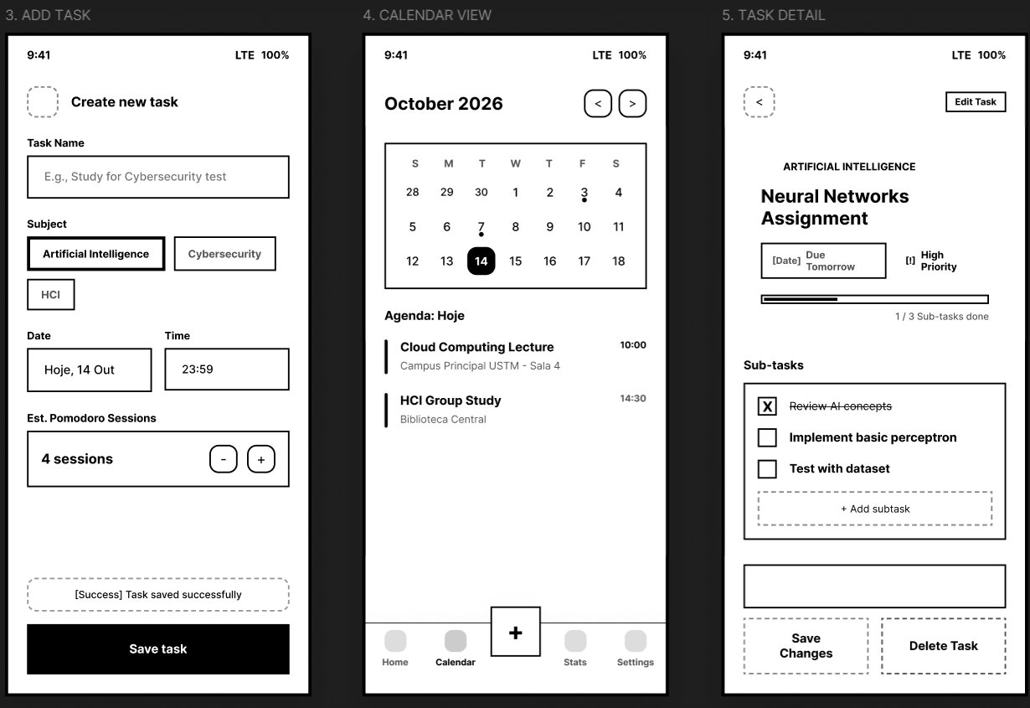
Figure 2 — Add Task (direct manipulation, thumb zone CTA), Calendar View (Gestalt continuity via timeline bars), Task Detail (error prevention via isolated Delete button)

Screens 6, 7 and 8: Focus Mode, Subject Manager and Progress Tracker
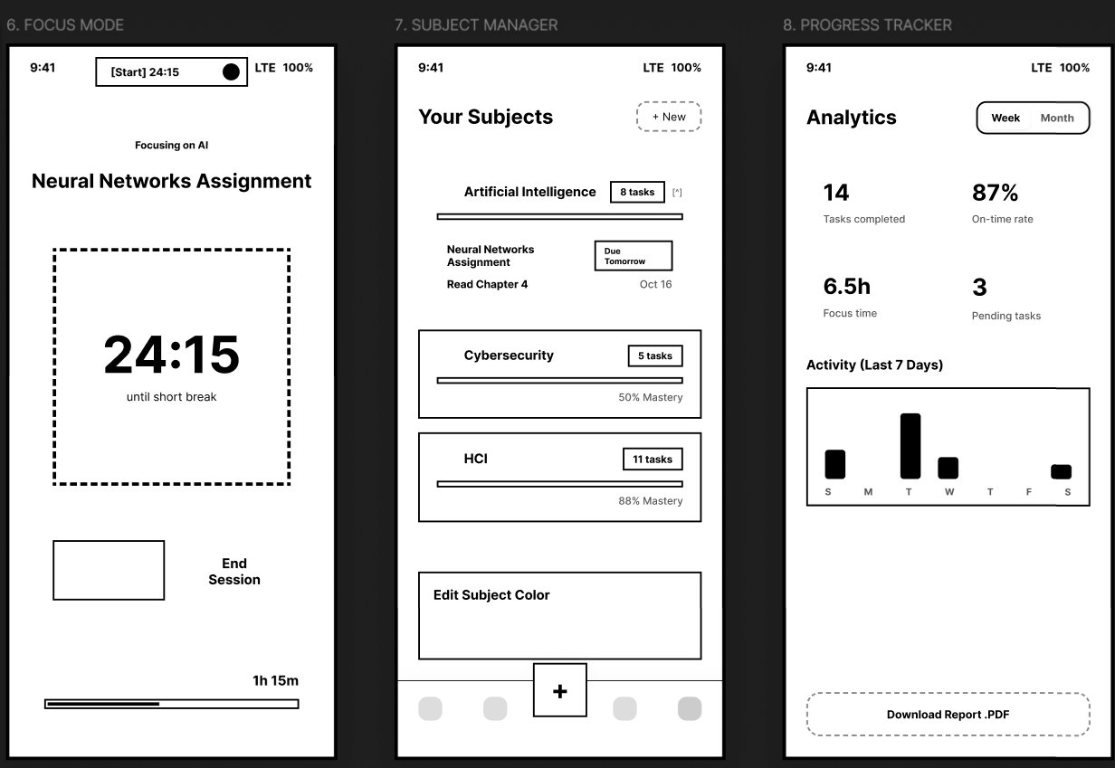
Figure 3 — Focus Mode (forcing function, minimalist design), Subject Manager (Gestalt similarity via colour coding), Progress Tracker (visibility of system status via stats grid and bar chart)

Screen 9: Settings and Notifications
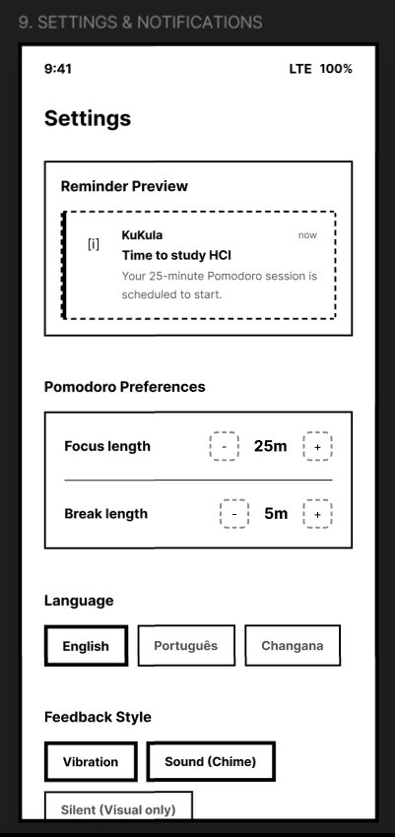
Figure 4 — Settings (recognition over recall via live notification preview, Pomodoro length stepper, language and feedback style chips)

Screen 0: Institutional Login  Entry point. Single CTA: 'Log in with University Email.' Language selector (English/Português/Changana) and Guest Mode link. Logo and tagline for brand orientation.  HCI Principle: Nielsen: Recognition over Recall, User Control & Freedom | Screen 1: Onboarding  Subject chip selector (AI, Blockchain, HCI, etc.). SIGA portal integration card. 3-step stepper shows progress. 'Continue to Dashboard' CTA.  HCI Principle: Norman: Mental Model alignment, Gestalt Common Region
Screen 2: Dashboard  Greeting with task count. Today/Upcoming/Done filter tabs. Task cards with progress bars and countdown badges. Offline Mode indicator badge.  HCI Principle: Nielsen: Visibility of System Status, High tap targets | Screen 3: Add Task  Task name input, subject chips, date/time pickers, Pomodoro session estimator (+/- stepper), and Save CTA with confirmation toast.  HCI Principle: Direct Manipulation, Thumb-zone friendly CTA positioning
Screen 4: Calendar View  Monthly grid with dot indicators per event type. Agenda list below with timeline bars colour-coded by subject. Navigation arrows for month.  HCI Principle: Gestalt: Continuity, Proximity — temporal grouping | Screen 5: Task Detail  Full task view with sub-task checklist. Progress bar (1/3 done). Priority badge. Three bottom actions: Begin Focus Session, Save Changes, Delete Task.  HCI Principle: Nielsen: Error Prevention — Danger button isolated
Screen 6: Focus Mode  Full-screen timer (dashed circle, 24:15 countdown). Dynamic Island live activity. 'Focusing on AI' badge. Minimalist design removes all navigation.  HCI Principle: Nielsen: Minimalist Design, Forcing Functions | Screen 7: Subject Manager  Subject cards with per-subject progress bars and task counts. Expandable card shows upcoming tasks. Colour editor for subject identity.  HCI Principle: Gestalt: Similarity — colour as cross-screen identifier
Screen 8: Progress Tracker  4-stat summary grid (tasks completed, on-time rate, focus time, pending). 7-day activity bar chart. 'Download Report .PDF' export.  HCI Principle: Nielsen: Visibility of System Status — standing at a glance | Screen 9: Settings  Notification preview card. Pomodoro length adjusters (+/-). Language chips. Feedback style selection (Vibration, Sound, Silent).  HCI Principle: Nielsen: Recognition vs Recall — live preview removes guesswork
Storyboard — Nádia's Evening Scenario

- Trigger: Nádia arrives home at 22:15, exhausted. KuKula sends a push notification: "You have 35 minutes before your usual sleep time. Your highest priority task is HCI Assignment."
- Interaction: She taps the notification. The app opens directly to the Task Detail screen for the HCI assignment, bypassing the dashboard entirely.
- Action: She taps Begin Focus Session. The interface enters Focus Mode, the navigation disappears, and the 25 minute Pomodoro timer starts.
- Completion: The session ends. The app shows a subtle animation confirming 1 session logged, her HCI progress bar advances, and her daily focus total updates in the Progress Tracker.
- Outcome: Nádia closes the app having accomplished one meaningful unit of work, with visible proof that she is keeping up, despite a demanding schedule.

5. Design Justification
Every major design decision in KuKula is defensible against core HCI and UX principles. The most significant are addressed below.

Offline Badge (Nielsen, Visibility of System Status). When the device loses connectivity, a clearly labelled Offline Mode badge appears in the top left of the Dashboard. Rather than silently failing or showing a disruptive error modal, the badge informs the user in a calm, non blocking way. This reflects an understanding that in Mozambique, intermittent connectivity is not an exception but a normal condition, and the interface must treat it accordingly.

Colour Coding (Gestalt Law of Similarity). Every subject is assigned a unique colour identifier during onboarding. That colour then propagates across every surface: task cards, calendar dots, progress bars and subject manager cards. The Gestalt Law of Similarity states that the brain groups elements sharing visual characteristics without explicit labelling. A student who has assigned blue to Artificial Intelligence can identify all related tasks at a glance, without reading a word. This substantially reduces cognitive load for fatigued users.

Floating Action Button (Norman, Affordance). The FAB (the large plus button centred in the bottom navigation bar) is the single most important affordance in the application. Its size, central position and visual weight signal that it is the primary creation action. It also respects the Thumb Zone principle from mobile UX: the bottom centre of a phone screen is the most naturally reachable area for single handed use, critical for a student navigating the app while standing on a chapa.

Task Detail Layout (Nielsen, Error Prevention). On the Task Detail screen, the Delete Task button is positioned in the lower right of a two column grid alongside Save Changes, while Begin Focus Session occupies the full width above. The Delete button uses a dashed, subdued border rather than the solid primary style, communicating that it is a destructive secondary action. This visual hierarchy makes the most dangerous action the least visually prominent, directly applying Nielsen's fifth heuristic.

Settings Notification Preview (Nielsen, Recognition over Recall). The Settings screen shows a live preview card of exactly how a push notification will appear on the lock screen before it is sent. Rather than asking the user to imagine what a reminder will look like, the interface shows them. The user recognises whether it matches their expectation and adjusts accordingly, without abstract mental simulation.

6. Usability Evaluation Plan

A. Heuristic Evaluation
I will conduct a structured walkthrough of all ten screens against Nielsen's 10 Usability Heuristics, recruiting a second peer evaluator who has not been involved in the design. Research by Nielsen and Molich (1990) shows two independent evaluators find significantly more usability issues than one. For each screen I will document: the heuristic violated, a severity rating (1 to 4 on Nielsen's scale), and a proposed fix. Areas of particular scrutiny include User Control and Freedom (can users exit Focus Mode without feeling penalised?), Consistency and Standards (are button styles and chip behaviours uniform across all screens?), and Error Recovery (if SIGES portal sync fails during onboarding, does the system offer a clear recovery path?).

B. User Testing Task List
I will recruit five USTM students representing both personas and ask each to interact with the prototype using the Think Aloud Protocol (Lewis, 1982), externalising their mental model so I can identify mismatches between my design assumptions and their actual understanding.

# | Task | Success Metric
1 | From the Dashboard, create a new task 'Study for Blockchain Exam' for tomorrow at 18:00, assigned to Blockchain, with 3 Pomodoro sessions. | Completion time, error count, navigation path
2 | Navigate to the Calendar and identify all academic obligations on the 15th of October. | Time to locate date, ability to read event types from visual cues
3 | Open the 'Neural Networks Assignment' and mark the first sub task as complete. | Steps taken, whether the progress bar update is noticed
4 | Start a Focus Session, let it run 30 seconds, then end the session and return to the Dashboard. | Ease of entry and exit, perceived control of the timer
5 | Navigate to Progress Tracker and identify which day this week had the most study activity. | Chart reading comprehension, time to answer
6 | Change the Pomodoro focus length from 25 to 35 minutes in Settings. | Discoverability of Settings, stepper interaction ease

7. Research Summary and References

Research Method 1: Contextual Inquiry
I observed five USTM students across two study sessions (Biblioteca Central and the main computer lab), watching silently as they attempted to organise their study plans. Students switched between WhatsApp, a browser (SIGES portal), a PDF reader and a notes application an average of eleven times before beginning to write a single assignment. Four out of five students kept a separate handwritten to do list because they did not trust digital reminders to surface at the right time. The most common verbal expression was a variation of "espera, onde estava isso?" ("wait, where was that?"), indicating severe context switching fatigue. These findings directly informed the Dashboard centralised task view, the Calendar, and the Offline Mode badge.

Research Method 2: Peer Survey
I distributed a digital questionnaire to 10 fellow students across 4th year Computer Science and Business Management. 84% reported feeling overwhelmed or disorganised about their academic schedule at least three times per week. 91% do not use a dedicated digital planner, citing reasons including "too complicated," "not built for our system," and "needs internet all the time." 79% said they would use a study app if it worked offline, required less than 2 minutes to set up each week, and showed their progress visually. These three findings map directly onto KuKula's three design pillars: offline first, low friction interaction, and visual progress feedback.

8. Conclusion
KuKula represents more than a mobile application prototype. It is an argument, made through design, that students in Mozambique deserve tools built for their reality, not tools built for a different context and reluctantly adapted. Every design decision in this project, from the offline badge to the colour-coded subjects to the Focus Mode forcing function, emerges from a genuine engagement with the lived experience of USTM students.

The theoretical framework underpinning this work, Norman's Gulf of Execution, Nielsen's Usability Heuristics, Shneiderman's Golden Rules, and Gestalt visual perception principles, provides the conceptual language to justify why these decisions are not just aesthetically pleasing but functionally correct. Good design, as Norman argues, should not require instruction. A student picking up KuKula for the first time should be able to add a task, start a focus session, and review their weekly progress within minutes, without reading a manual, without watching a tutorial, and without worrying about data costs or connectivity.

The usability evaluation plan I have outlined, combining heuristic expert review with empirical user testing and a structured post-test questionnaire, will produce the evidence needed to refine the prototype into a high-fidelity product that can genuinely serve the USTM community. KuKula is designed to grow with its users. And so, in every meaningful sense, will I as a designer through this process.

Post Test Questionnaire
# | Question | Scale | HCI Principle
1 | I was able to find the information I needed quickly without getting lost. | Likert 1 to 5 | Nielsen H6: Recognition over Recall
2 | The navigation between screens felt natural and logical. | Likert 1 to 5 | Norman: Mental Models
3 | The colour coding helped me identify which subject a task belonged to without reading the text. | Likert 1 to 5 | Gestalt: Similarity
4 | The progress bars gave me a clear sense of how much work remained. | Likert 1 to 5 | Nielsen H1: System Status
5 | During Focus Mode, I felt in control of the timer and knew how to end the session. | Likert 1 to 5 | Nielsen H3: User Control
6 | The removal of navigation during Focus Mode helped me concentrate. | Likert 1 to 5 | Norman: Forcing Functions
7 | The language options (English, Português, Changana) made me feel this app was designed for students like me. | Likert 1 to 5 | Nielsen H2: Real World Match
8 | I would trust KuKula to manage my university deadlines without missing anything. | Likert 1 to 5 | Trust / Reliability
9 | What was the single most confusing moment during your interaction? What did you expect vs. what happened? | Open ended | Qualitative insight
10 | Which one feature would make the biggest difference to your academic routine if available on your phone today? | Open ended | Feature prioritisation

HCI and UX Theory References
- Norman, D. A. (2013). The Design of Everyday Things (Revised Edition). Basic Books.
- Nielsen, J. (1994). 10 Usability Heuristics for User Interface Design. Nielsen Norman Group.
- Shneiderman, B. et al. (2016). Designing the User Interface (6th ed.). Pearson.
- Nielsen, J. and Molich, R. (1990). Heuristic evaluation of user interfaces. CHI '90 Conference Proceedings, 249 to 256.
- Lewis, C. (1982). Using the 'Thinking Aloud' Method in Cognitive Interface Design. IBM Research Report.
- Fogg, B. J. (2019). Tiny Habits: The Small Changes That Change Everything. Houghton Mifflin Harcourt.

References
- Norman, D. A. (2013). The Design of Everyday Things (Revised and Expanded Edition). Basic Books.
- Nielsen, J. (1994). 10 Usability Heuristics for User Interface Design. Nielsen Norman Group.
- Shneiderman, B., Plaisant, C., Cohen, M., Jacobs, S., Elmqvist, N., & Diakopoulos, N. (2016). Designing the User Interface: Strategies for Effective Human-Computer Interaction (6th ed.). Pearson.
- Nielsen, J., & Molich, R. (1990). Heuristic evaluation of user interfaces. Proceedings of the CHI '90 Conference on Human Factors in Computing Systems, 249–256.
- Lewis, C. (1982). Using the 'Thinking-Aloud' Method in Cognitive Interface Design. IBM Research Report.
- Fogg, B. J. (2019). Tiny Habits: The Small Changes That Change Everything. Houghton Mifflin Harcourt.
- Deci, E. L., & Ryan, R. M. (1985). Intrinsic Motivation and Self-Determination in Human Behavior. Springer.
- Krug, S. (2014). Don't Make Me Think, Revisited: A Common Sense Approach to Web Usability (3rd ed.). New Riders.

